2025 Graduation Thesis Abstract
Student Number | A2177802
Name (Laboratory) | Karter Wong (Hidetake Tanaka Lab.)
Title | Development of a CAM System for Incremental Forming of CFRTP from 3D CAD Data
Purpose of Research:
In recent years, various industries have shifted to materials like carbon fiber-reinforced thermoplastics for manufacturing products in both large and small quantities at varying levels of complexity. Using traditional molding methods for low-volume, complex shapes can be impractical due to the high initial cost of the mold. Incremental forming offers a cost-effective solution for smaller-volume, complex products, as it is a mold less machining method. The objective of this research is to enhance and test the previously created CAM system's ability to generate accurate toolpaths for complex geometries.
Research Overview:
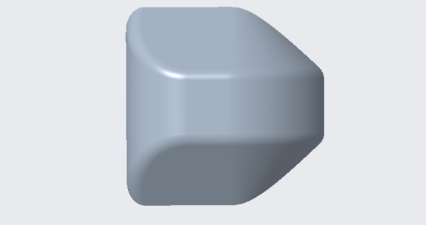
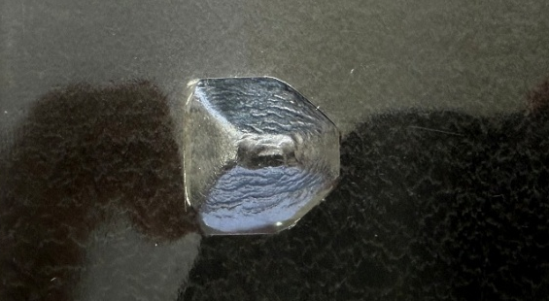
The workflow of the CAM system, as observed in the previous and current study, involves taking the 3D CAD data from an STL file, then sorting, removing, manipulating, and converting the points from Gaussian coordinates to G-code to form the toolpath; then loaded into a CNC machine and run. The CAM system utilizes Python libraries, custom logic modules, and variables to optimize the toolpath generation manipulating points as needed. Four types of experiments were conducted using the generated toolpath, varying between two test material and whether a mold was used. The target shape was a 30 mm x 30 mm x 9.9 mm rectangular prism with chamfered and rounded sides.
≈ 30 mm
≈ 30 mm
Figure 1: Test Shape Used in the Experiment [Wong, 2025]

Figure 2: Formed Workpiece [Wong, 2025]

Results:
The updated CAM system significantly reduced toolpath generation time for a complex test shape from 2.5 hours to 2 seconds. The tests demonstrated that the toolpath of the enhanced CAM system worked. The tests with a mold achived better results, consistently forming depths ranging from 8 to 10 mm and retaining the test shape better than in the tests without the mold. The system excels in handling complex geometries and streamlining manufacturing, but further research is needed to optimize CFRTP forming and enhance analysis methods.
Reference:
[1] Tatsuki Ikari, Hidetake Tanaka, Feasibility Study of Single-Point Incremental Forming for DiscontinuousFibre CFRP using oil bath heating International Journal of Automation Technology, Vol. 18, No. 3, 433-
443, 2024
[2] Hidetake Tanaka, Kippei Yamada and Tatsuki Ikari, Feasibility Study of Laser-assisted Incremental
Forming for CFRTP based on 3D-CAD data, International Journal of Automation Technology, Vol. 17, No. 2, 144-155,2023

